**Table Creation:**

**User table:**

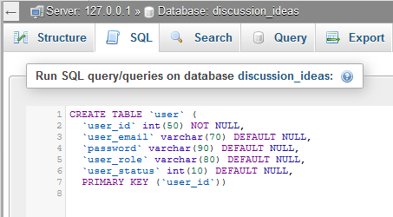

Figure 01: Table creation code of user table

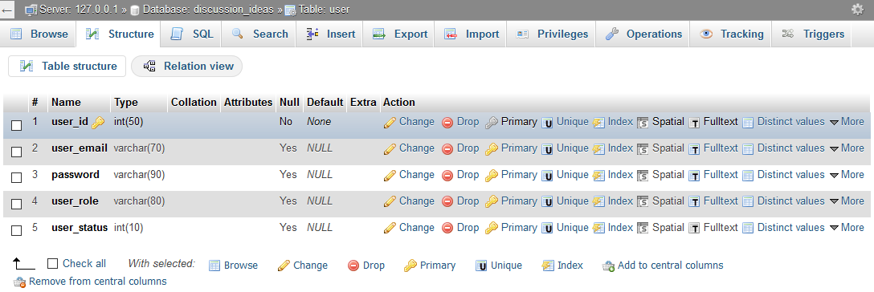

Figure 02: Structure of user table

**Staff_type table:**

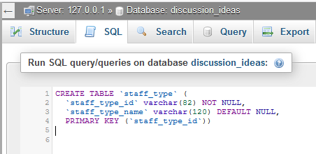

Figure 03: Table creation code of Staff_Type Table

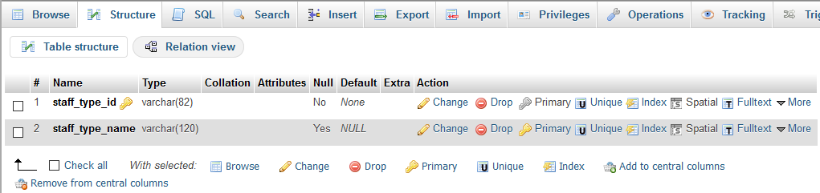

Figure 04: Structure of Staff_Type table

**Department table:**

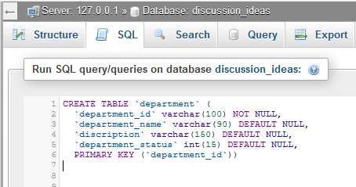

Figure 05: Table creation code of department table

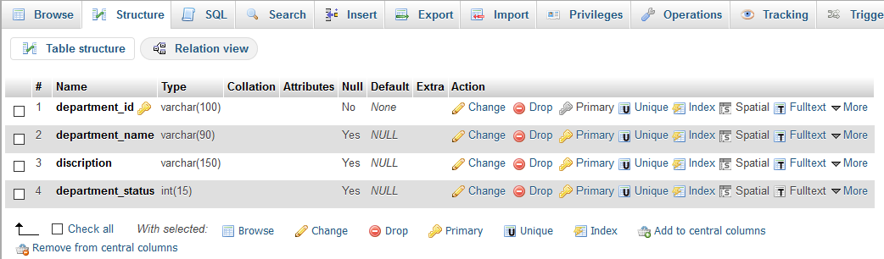

Figure 06: Structure of department table

**Staff table:**

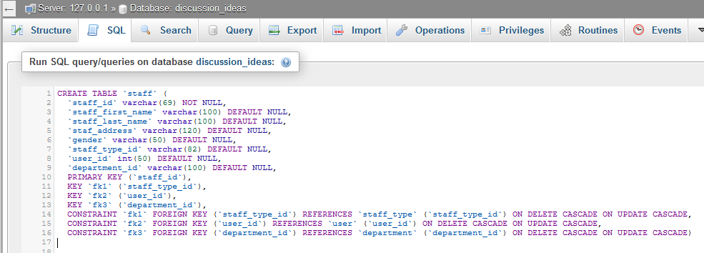

Figure 07: Table creation code of staff table

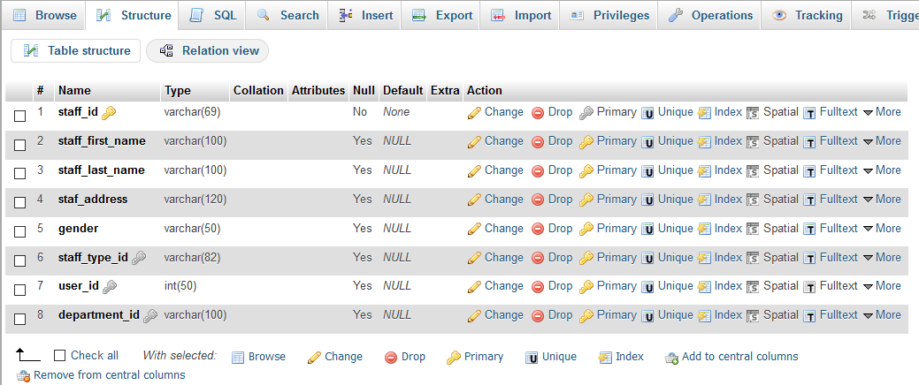

Figure 08: Structure of staff table

**Student table:**

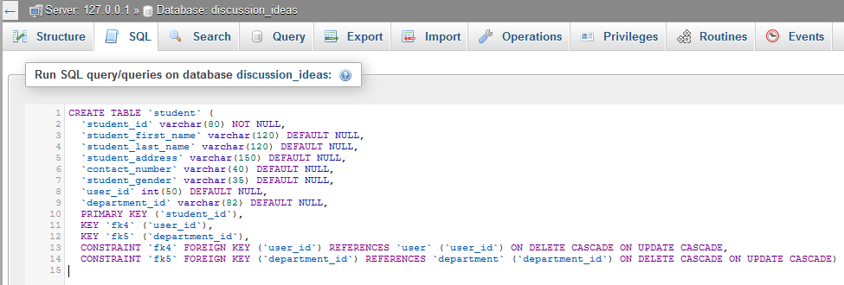

Figure 09: Table creation code of student table

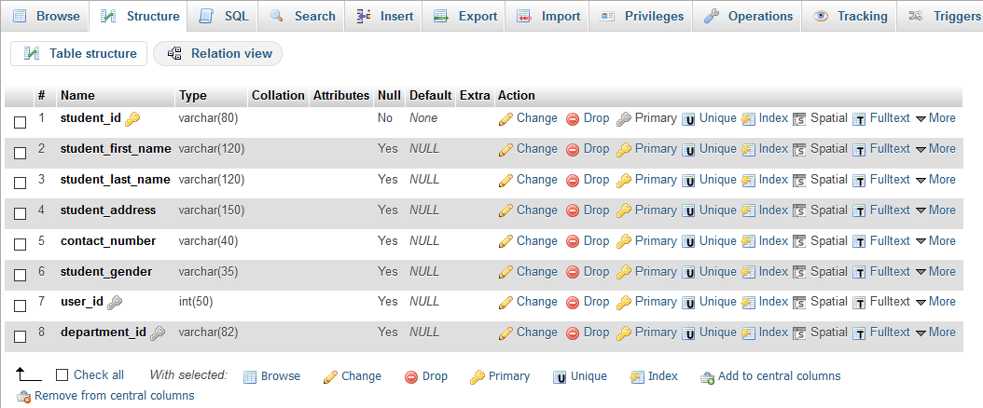

Figure 10: Structure of student table

**Topic table:**

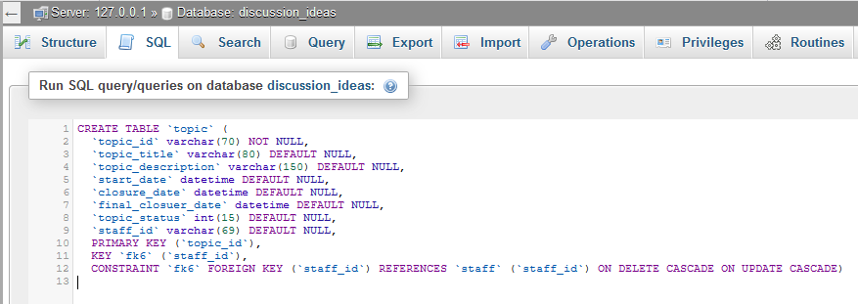

Figure 11: Table creation code of topic table

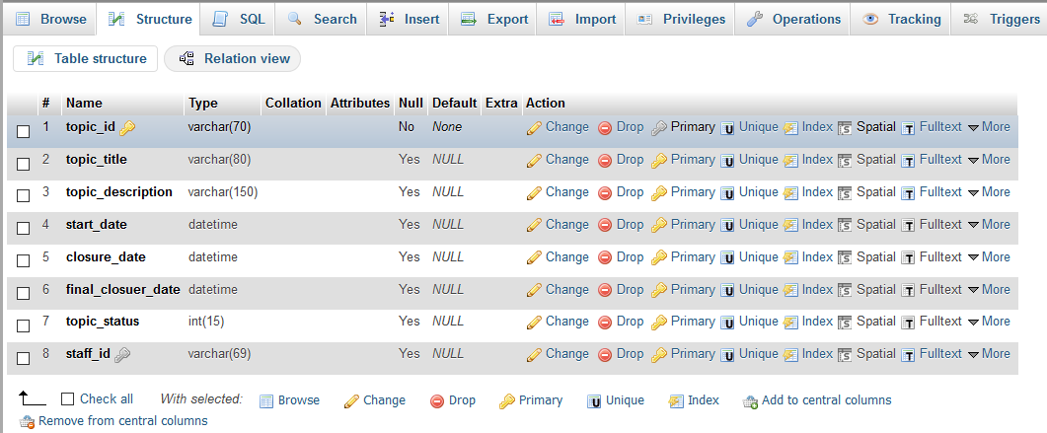

Figure 12: Structure of topic table

**Idea table:**

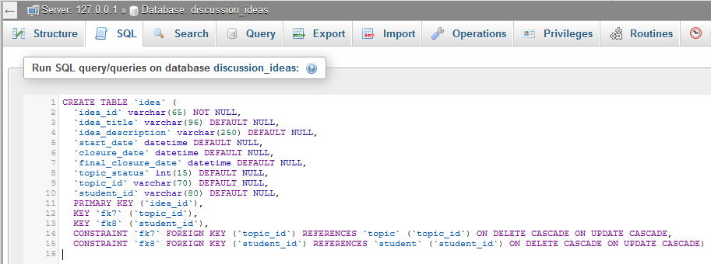

Figure 13: Table creation code of idea table

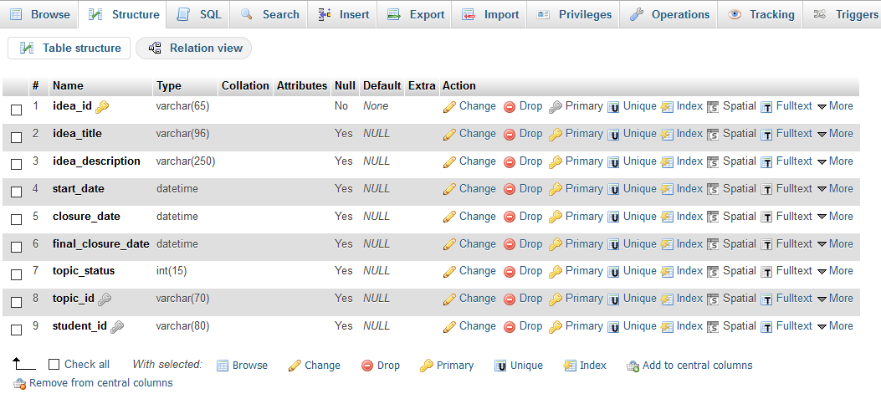

Figure 14: Structure of idea table

**Attachment table:**

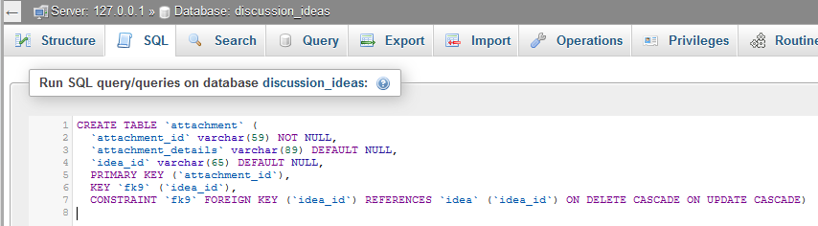

Figure 15: Table creation code of attachment table

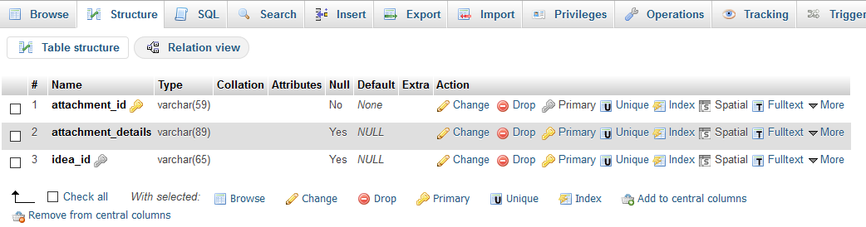

Figure 16: Structure of attachment table

**Comment Table:**

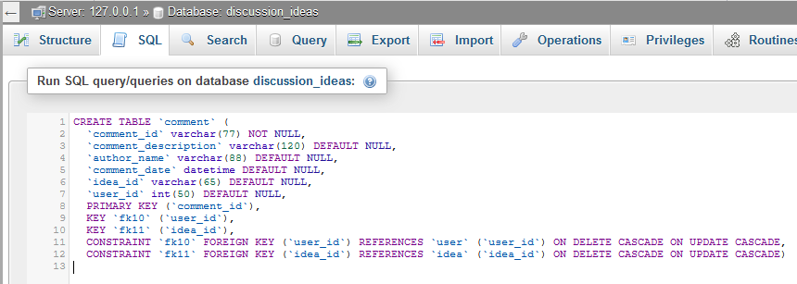

Figure 17: Table creation code of comment table

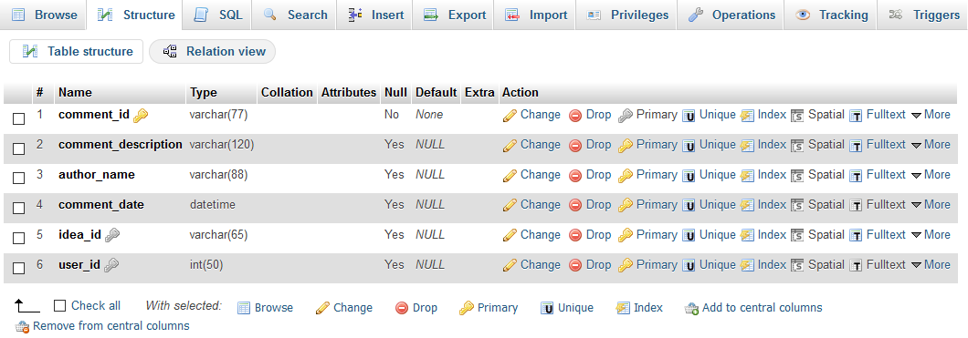

Figure 18: Structure of comment table

**Reaction table:**

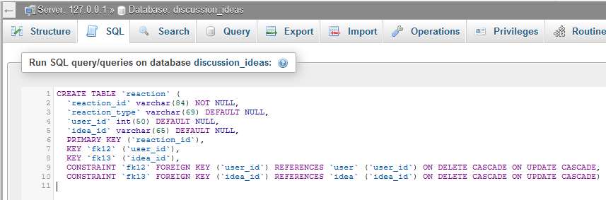

Figure 19: Table creation code of reaction table

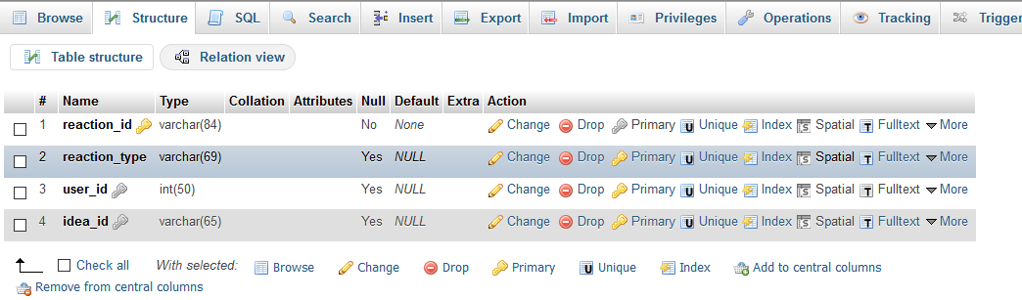

Figure 20: Structure of reaction table